12th Conference on Learning Factories, CLF2022

A Sustainability Framework for Smart Learning Factories Based on Using Structured Information as Semantic Models

*[1]

Abstract

© 2022 The Authors. This is an open access article.

Peer Review statement: Peer-review under responsibility of the scientific committee of the 12th Conference on Learning Factories 2022.

*Keywords:*

1. Introduction

Background & Motivation

Sustainability Framework introduction

1. Literature Review

What others have done

Research challenges and Gaps

1. Semantic Interoperability

Semantic interoperability enables that computer systems manage/exchange data with common understanding by explicit and distributed meaning. As Industry 4.0 has been highlighted, it happens very often that manufacturing companies have to consider data federation between various data sources. Generally speaking, efficient management of the ecosystem can be done by exploiting not only field device data but also business data from MES/ERP and business systems. However, the origin of field device data is different from business data, and each sort of data has its data format. To overcome this challenge, semantic interoperability is a priority requirement to enable data federation. It is accomplished by linking each data element to an ontology which provides the capability of machine interpretation with logic by shared vocabulary.

Sustainability semantic/data model and learning factory/manufacturing data model are designed as a knowledge representation of the manufacturing ecosystem for standardization and generalization. They support graph DB and provide interoperability for interconnection between IoT devices. Especially, both semantic models enable the management/exchange of data with common understanding by explicit and distributed meaning. It is accomplished by linking each data element to semantic models which provides the capability of machine interpretation with logic by shared vocabulary. In addition, semantic models provide the common vocabulary that allows for this data to be understood the same way across different systems beyond the ecosystem. They help mark-up graph data with meaningful meta-data. Through graph data, it is possible to identify different entities along an assembly line, for example, a specific machine, or a specific process in digital twin. Graph data helps linking entities to each other, and also link entities to their data.

1. Sustainability Framework for Learning Factory

Why in Manufacturing

Sustainability has been one of the keywords in manufacturing for the last couple of decades. After the Industrial revolution, the exploitation of natural resources has been increased exponentially. Therefore, the natural resources have been depleted and the environment has been damaged. Presenting the flow of the resources during the product lifecycle, this manufacturing environment is called ‘linear economy’. The linear economy caused the unsustainability problem in long term due to the degradation of natural resources and the accumulation of waste. Therefore, many manufacturing companies attempt to switch from a linear to a circular economy. Whereas the linear economy is a ‘take, make, dispose of model’, the circular economy is keeping the natural resources as much as possible and eliminating waste by focusing on ‘made to last long and to be made again model’. The three principles of recycling and reuse of materials for ensuring healthy and safe living and working conditions are: i) preserve and enhance natural capital by controlling finite stocks and balancing renewable resource flows, ii) optimize resource yields by circulating products, components and materials in use at the highest utility at all times in both technical and biological cycles, and iii) Foster system effectiveness by revealing and designing out negative externalities [1]. Therefore, strict environmental regulations on disposing of products, e.g. end-of-life vehicle directive of EU and directive on waste electrical and electronic equipment, go into effect. The manufacturing companies have to preserve and extend what is already made, prioritize regenerative resources, and use waste as a resource and rethink the business model [2]. The circular economy facilitates the involvement of new product design, new supply chains, new business strategies. During Product Life Cycle (PLC), the circular economy approach could be summarized as follows: i) Design (BOL) - Eco-Design: a preventive and proactive approach to integrating the environment during the design phase of product and services, ii) Manufacturing (BOL) - Cleaner production: an approach to cleaner production over the long term by reducing emissions and waste, iii) Use (MOL) - Eco-Maintenance: principles of ‘cleaner production’ applied to the maintenance process, and Maintenance: Using maintenance tools to determine when equipment can no longer be remanufactured, and iv) Retirement (EOL) – Waste management: Waste management by collecting, transporting, processing and enhancing, Closed-Loop Supply Chain: approach to maximize the value creation of a product over its entire life cycle taking into account returns, Remanufacturing: Industrial process to restore to a product that has already been used a level of performance equivalent to that of a new product, Repurposing: Industrial process to reuse a product that has already been used in other applications than the one for which it was designed, Recycling, Energy valorization, and Disposal.

Why Sustainability Cloud

The advent of Industry 4.0 facilitates efficient monitoring/forecast of energy consumption through the cloud. Advanced industry 4.0 technologies involve collecting identification and sensor data, plus any other kind of useful ‘lifecycle event’ data. This is then filtered and aggregated into meaningful information through cloud computing. The information may then be converted into knowledge by applying decision support or other analysis routines, using Artificial Intelligence (AI) and Machine Learning (ML). Ultimately the resulting knowledge may be fed back into the various processes which make up the total life of the product or service. In the form of the digital twin, packaging the above technologies presents micro-controls and feedbacks during the manufacturing processes in real-time. However, despite the requirements to achieve sustainable manufacturing toward the circular economy, companies are immature to exploit the advent of new technologies. In addition, the research works have been very active in each application of the newly emphasizing technologies. Nevertheless, it has been less motivated to tackle a problem with integration of them and each domain has separated from others. For this reason, it is the lack of guidelines to address problems with the aggregation of those technologies, even though advanced technologies such as big data and analytics, horizontal and vertical system integration, and the cloud have been improved rapidly. Therefore, it is required to develop a new method deeply considering the aggregation of advanced technologies, which increases manufacturing sustainability and reduces the consumption of natural resources. This improvement supports companies to survive in a competitive manufacturing environment and to decrease costs from unnecessary use of resources.For this reason, a sustainability framework for smart learning factories is proposed as a reference and guideline for the design of ecosystems in manufacturing.

Reference Architecture Framework

The proposed sustainability framework is comprised of Ingestion, process layer and twin/model storage, analytical, and presentation as follows:

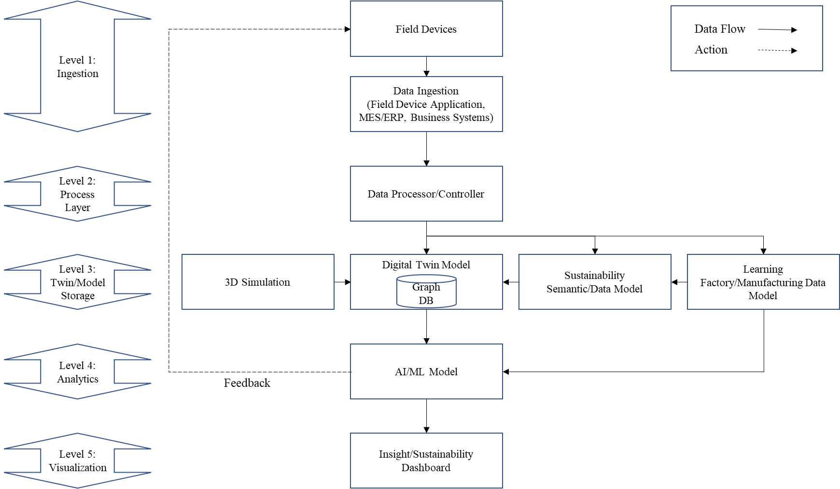

Fig. 1. Sustainability framework

* 1. Ingestion

The future enhancement of field devices and their operational performance will lay on the development and implementation of innovative sensor monitoring systems [3]. As an efficient way, IoT plays the role of promising transformational solutions for the operation of many existing industrial systems within the digital enterprises of tomorrow’s complex industrial ecosystems [4]. In addition, it provides end-to-end transparency almost in real-time, allowing improvement of the manufacturing environment [5]. A seamless interconnection between IoT devices facilitates the process of sharing, gathering, and creating information without human intervention [6]. Further on, MES/ERP and Business systems are involved to analyze the comprehensive manufacturing ecosystem.

This layer allows us to bring various data from various desperate data sources form factory or plant floor and also from other business systems like ERP, CRM, Warranty, Supply chain from the corporate. Ingestion covers various type like event based, or streaming data and also batch based data into our system. Given plant or manufacturing has various software and services from multiple vendors. Each vendor or software might have their own way of data collection and processing, but we would like to bring data from these systems and bring to central location for further analytics.

* 1. Process Layer

A data processor/controller is the paramount importance for the management of collected data. In this phase, collected data is being validated as its format is transformed into a certain form or language. Gölzer et al. (2015) analyzed the requirements of data processing [7]. They are categorized into decision processing, knowledge processing, and real-time processing.

Process is transformation engine that process the ingestion data and then does the business process transformation and then land to destination data models. This is where most translation or translate data such as quality, business transformation and other data cleaning. Majority of data processing will happen in this layer.

* 1. Twin/Model Storage

3D simulation provides a basis for a digital twin. It represents a virtual manufacturing ecosystem corresponding to the real world. The digital twin model includes graph DB to make efficient relations between IoT devices. Graph DB, together with semantic models, has strengths in extensibility and reusability of knowledge. Sustainability semantic/data model and learning factory/manufacturing data model are designed as a knowledge representation of the manufacturing ecosystem for standardization and generalization. They are used for structuring and understanding data in the digital twin model.

* 1. Analytical

Decentralized decisions lie in the interconnection of objects and people as well as transparency on information from inside and outside of a manufacturing facility [3]. The replacement of organizational decision-making to decentralized decreases costs of information technology in many situations, and bringing decentralized and centralized together make a better decision than isolated local decision-makers [8]. This idea can be applied to Industry 4.0 solution with the purpose of reduction of unnecessary energy consumption, especially for Big data analytics. Because big data analysis is a time and resource-consuming task, creating a decentralized decision-making tool will bring cost benefits.

This layer concentrates on using the data to make analytical insights. Here semantic and logical data models are built. The data is stored doesn’t provide value without applying analytics. Here is where we collect and process and store sustainability datasets and also other Manufacturing datasets and model to store what is happening in manufacturing. Data collection is stored Sustainability and also Manufacturing Learning factory model. Models built here are analytical purpose and also agile in nature to accommodate the ever changing manufacturing domain with new innovations and digital transformation that is happening.

* 1. Presentation

Due to the increasing complexity of production, the main role of humans shifts from an operator of machines to a strategic decision-maker and a flexible problem-solver [3]. Meanwhile human needs technical support to understand the operation of very complicated system instinctively. The technical assistance includes acquisition, aggregation, visualization, and re-use of data and information [9].

This layer provides access to knowledge workers to take data driven decision by providing insights through mobile, web or dashboard type applications. Some time it would be push notifications or pull based. Providing insights with context is allows to increase productivity for the workers and increases efficiency.

1. Implementation details

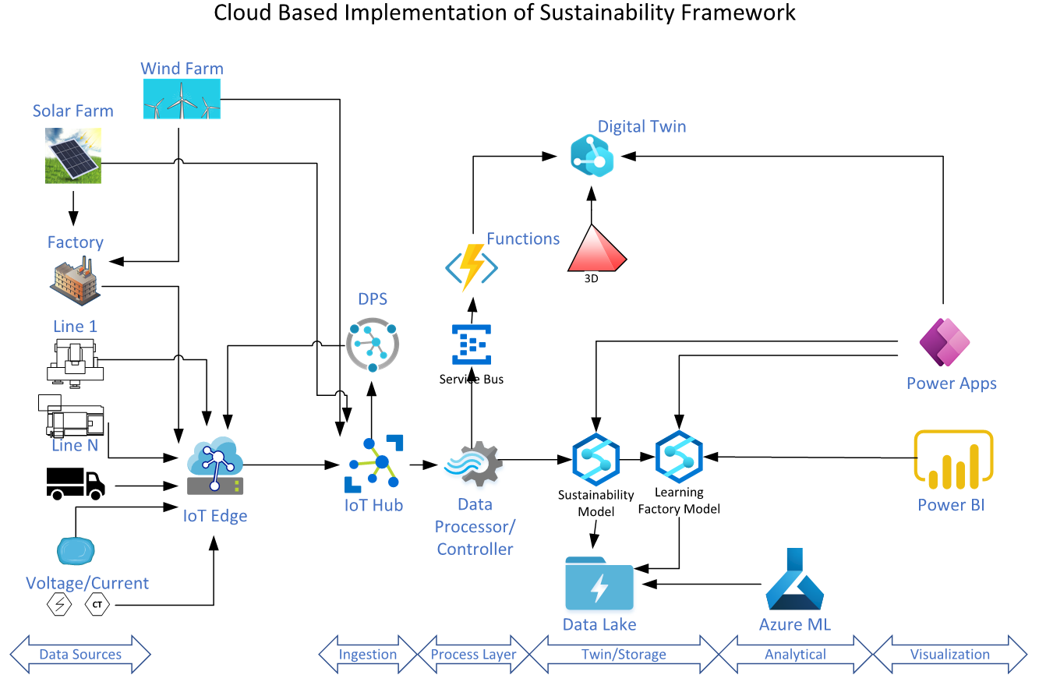

Fig. 2. Sustainability implementation

Bala to add text here

The above implementation considers to follow through the above system designed. The implementation goes from left to right, IoT Edge is used for factory or plant floor to collect the data from various sources and package it in the right way to send out to the cloud. On the Right side starting from Ingestion is where the cloud plays a role. IoT hub is gateway to cloud to send the data securely into cloud. Iot cloud can intake event based or stream based. For Batch based we might use other way to push data into the cloud. Following IoT hub Data processor/controller does the data transformation/translation and business process and save the data into Digital Twin for current status and also saving into Sustainability model to store the data into proper sustainability model and then the manufacturing exection data lands in manufacturing learning factory data model. The reason is sustainability is stored separately to collect data form various internal and external data sources to accurately report sustainability across manufacturing. We do provide option to machine learning or deep learning modelling using Azure machine learning tools, and data processing using synapse analytics and using Azure digital twin to send data to twins. Visualation is provided by power bi and power apps to cover various visualizations.

1. Future Work & Conclusion

Acknowledgements

References

[1] MacArthur, E. (2013). Towards the circular economy. Journal of Industrial Ecology, 2, 23-44.

[2] Burger, M., Stavropoulos, S., Ramkumar, S., Dufourmont, J., & van Oort, F. (2019). The heterogeneous skill-base of circular economy employment. Research Policy, 48(1), 248-261.

[3] Teti, R., Jemielniak, K., O’Donnell, G., & Dornfeld, D. (2010). Advanced monitoring of machining operations. CIRP annals, 59(2), 717-739.

[4] Xu, L. D., Xu, E. L., & Li, L. (2018). Industry 4.0: state of the art and future trends. International Journal of Production Research, 56(8), 2941-2962.

[5] Shrouf, F., Ordieres, J., & Miragliotta, G. (2014, December). Smart factories in Industry 4.0: A review of the concept and of energy management approached in production based on the Internet of Things paradigm. In 2014 IEEE international conference on industrial engineering and engineering management (pp. 697-701). IEEE.

[6] Bello, O., & Zeadally, S. (2014). Intelligent device-to-device communication in the internet of things. IEEE Systems Journal, 10(3), 1172-1182.

[7] Gölzer, P., Cato, P., & Amberg, M. (2015). Data processing requirements of industry 4.0-use cases for big data applications.

[8] Malone, T. (2003). Is empowerment just a fad? Control, decision making, and IT. Inventing the Organizations of the 21st Century, 49-69.

[9] Gorecky, D., Schmitt, M., Loskyll, M., & Zühlke, D. (2014, July). Human-machine-interaction in the industry 4.0 era. In 2014 12th IEEE international conference on industrial informatics (INDIN) (pp. 289-294). Ieee.

1. * Corresponding author. Tel.:

   *E-mail address:*